Comprehensive Assignment 10
Evidence
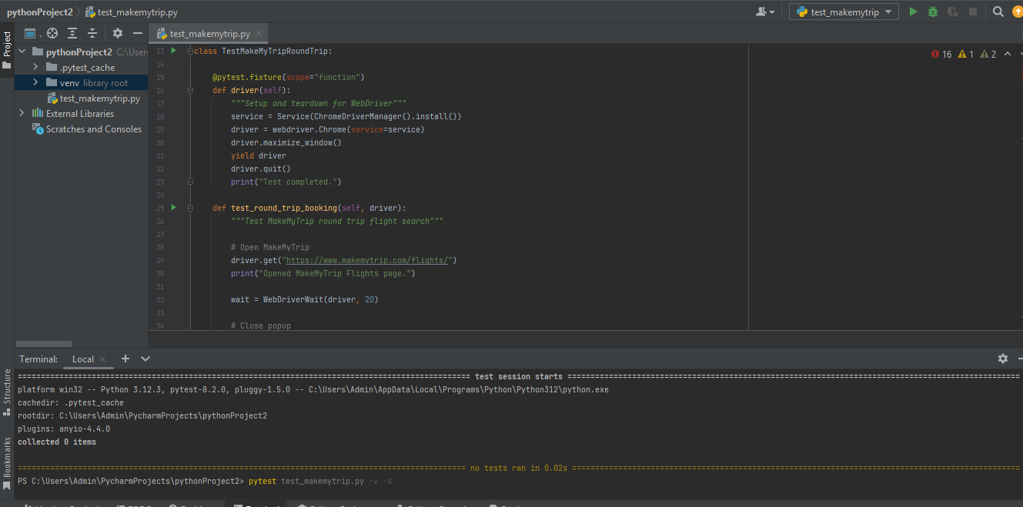
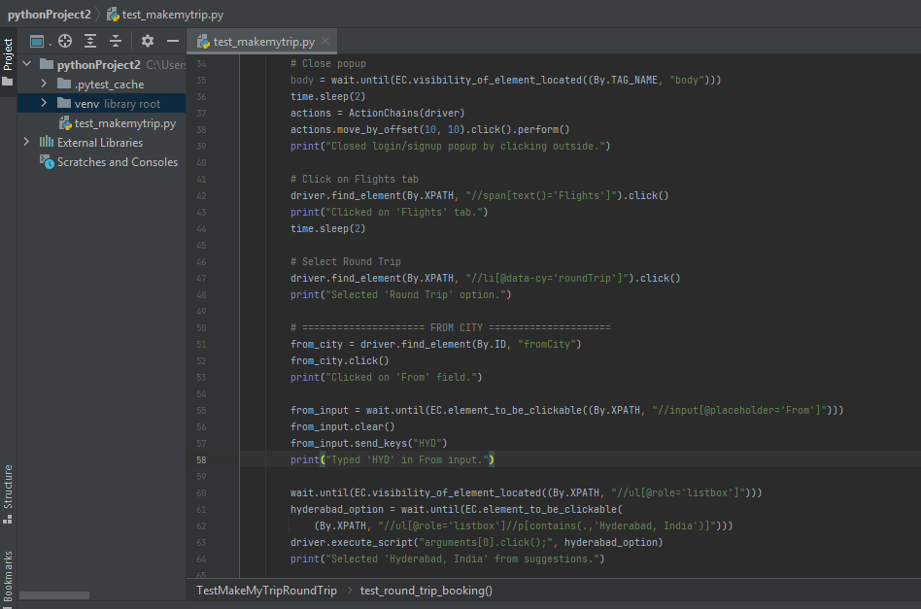
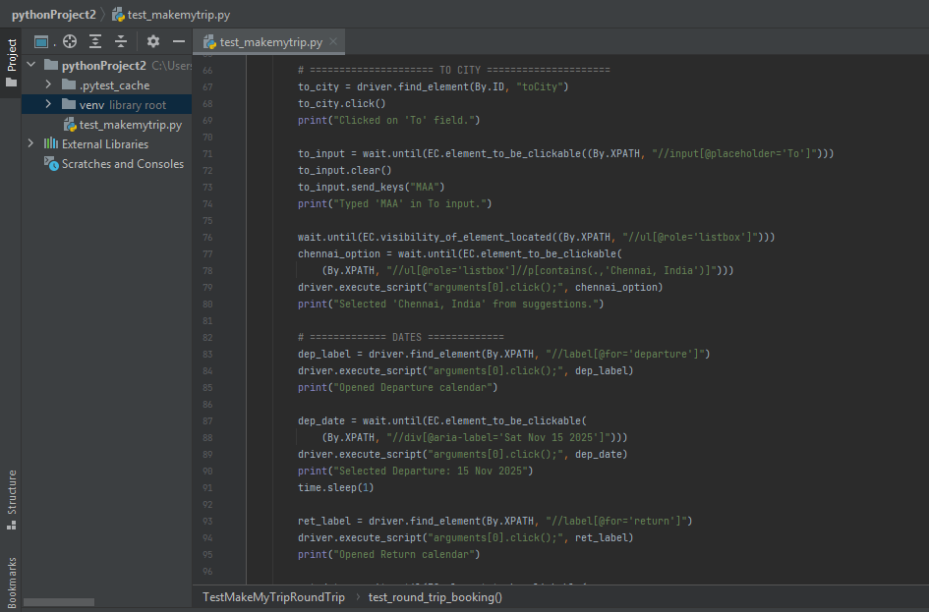
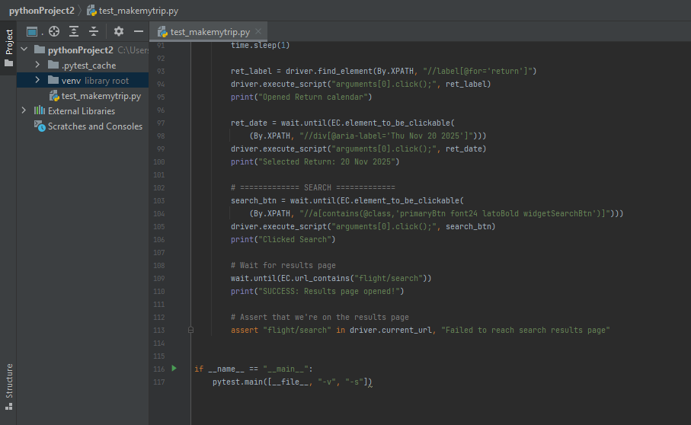

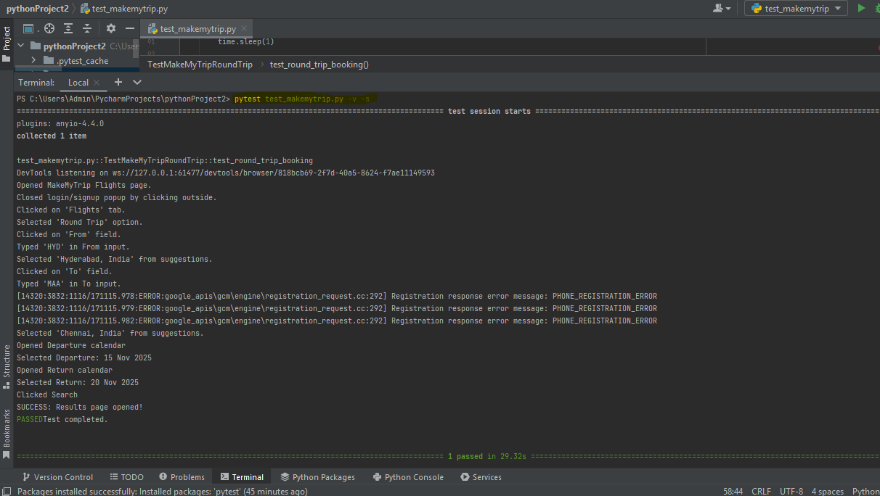
import pytest
from selenium import webdriver
from selenium.webdriver.common.by import By
from selenium.webdriver.support.ui import WebDriverWait
from selenium.webdriver.support import expected_conditions as EC
from selenium.webdriver.common.action_chains import ActionChains
from selenium.webdriver.common.keys import Keys
from webdriver_manager.chrome import ChromeDriverManager
from selenium.webdriver.chrome.service import Service
import time
class TestMakeMyTripRoundTrip:
@pytest.fixture(scope="function")
def driver(self):
"""Setup and teardown for WebDriver"""
service = Service(ChromeDriverManager().install())
driver = webdriver.Chrome(service=service)
driver.maximize_window()
yield driver
driver.quit()
print("Test completed.")
def test_round_trip_booking(self, driver):
"""Test MakeMyTrip round trip flight search"""
# Open MakeMyTrip
driver.get("https://www.makemytrip.com/flights/")
print("Opened MakeMyTrip Flights page.")
wait = WebDriverWait(driver, 20)
# Close popup
body = wait.until(EC.visibility_of_element_located((By.TAG_NAME, "body")))
time.sleep(2)
actions = ActionChains(driver)
actions.move_by_offset(10, 10).click().perform()
print("Closed login/signup popup by clicking outside.")
# Click on Flights tab
driver.find_element(By.XPATH, "//span[text()='Flights']").click()
print("Clicked on 'Flights' tab.")
time.sleep(2)
# Select Round Trip
driver.find_element(By.XPATH, "//li[@data-cy='roundTrip']").click()
print("Selected 'Round Trip' option.")
# ===================== FROM CITY =====================
from_city = driver.find_element(By.ID, "fromCity")
from_city.click()
print("Clicked on 'From' field.")
from_input = wait.until(EC.element_to_be_clickable((By.XPATH, "//input[@placeholder='From']")))
from_input.clear()
from_input.send_keys("HYD")
print("Typed 'HYD' in From input.")
wait.until(EC.visibility_of_element_located((By.XPATH, "//ul[@role='listbox']")))
hyderabad_option = wait.until(EC.element_to_be_clickable(
(By.XPATH, "//ul[@role='listbox']//p[contains(.,'Hyderabad, India')]")))
driver.execute_script("arguments[0].click();", hyderabad_option)
print("Selected 'Hyderabad, India' from suggestions.")
# ===================== TO CITY =====================
to_city = driver.find_element(By.ID, "toCity")
to_city.click()
print("Clicked on 'To' field.")
to_input = wait.until(EC.element_to_be_clickable((By.XPATH, "//input[@placeholder='To']")))
to_input.clear()
to_input.send_keys("MAA")
print("Typed 'MAA' in To input.")
wait.until(EC.visibility_of_element_located((By.XPATH, "//ul[@role='listbox']")))
chennai_option = wait.until(EC.element_to_be_clickable(
(By.XPATH, "//ul[@role='listbox']//p[contains(.,'Chennai, India')]")))
driver.execute_script("arguments[0].click();", chennai_option)
print("Selected 'Chennai, India' from suggestions.")
# ============= DATES =============
dep_label = driver.find_element(By.XPATH, "//label[@for='departure']")
driver.execute_script("arguments[0].click();", dep_label)
print("Opened Departure calendar")
dep_date = wait.until(EC.element_to_be_clickable(
(By.XPATH, "//div[@aria-label='Sat Nov 15 2025']")))
driver.execute_script("arguments[0].click();", dep_date)
print("Selected Departure: 15 Nov 2025")
time.sleep(1)
ret_label = driver.find_element(By.XPATH, "//label[@for='return']")
driver.execute_script("arguments[0].click();", ret_label)
print("Opened Return calendar")
ret_date = wait.until(EC.element_to_be_clickable(
(By.XPATH, "//div[@aria-label='Thu Nov 20 2025']")))
driver.execute_script("arguments[0].click();", ret_date)
print("Selected Return: 20 Nov 2025")
# ============= SEARCH =============
search_btn = wait.until(EC.element_to_be_clickable(
(By.XPATH, "//a[contains(@class,'primaryBtn font24 latoBold widgetSearchBtn')]")))
driver.execute_script("arguments[0].click();", search_btn)
print("Clicked Search")
# Wait for results page
wait.until(EC.url_contains("flight/search"))
print("SUCCESS: Results page opened!")
# Assert that we're on the results page
assert "flight/search" in driver.current_url, "Failed to reach search results page"
if __name__ == "__main__":
pytest.main([__file__, "-v", "-s"])

